Ryan G. Cooper

Professor Conlan

CS-405 Module 5 Assignment Two

June 9th, 2024

**Encryption Code**

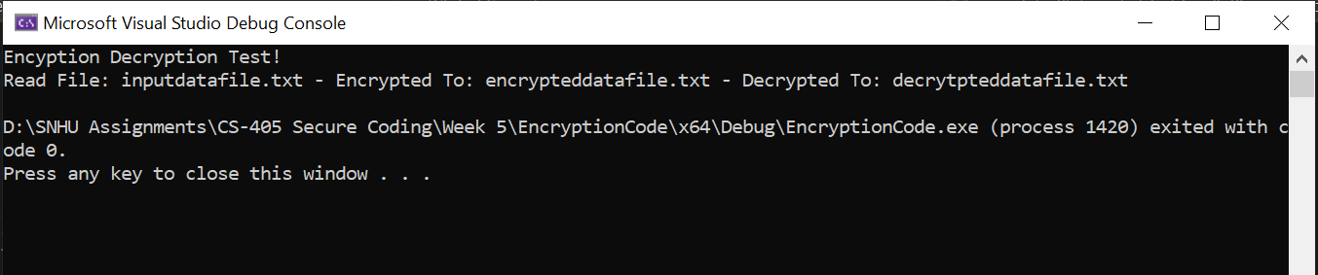

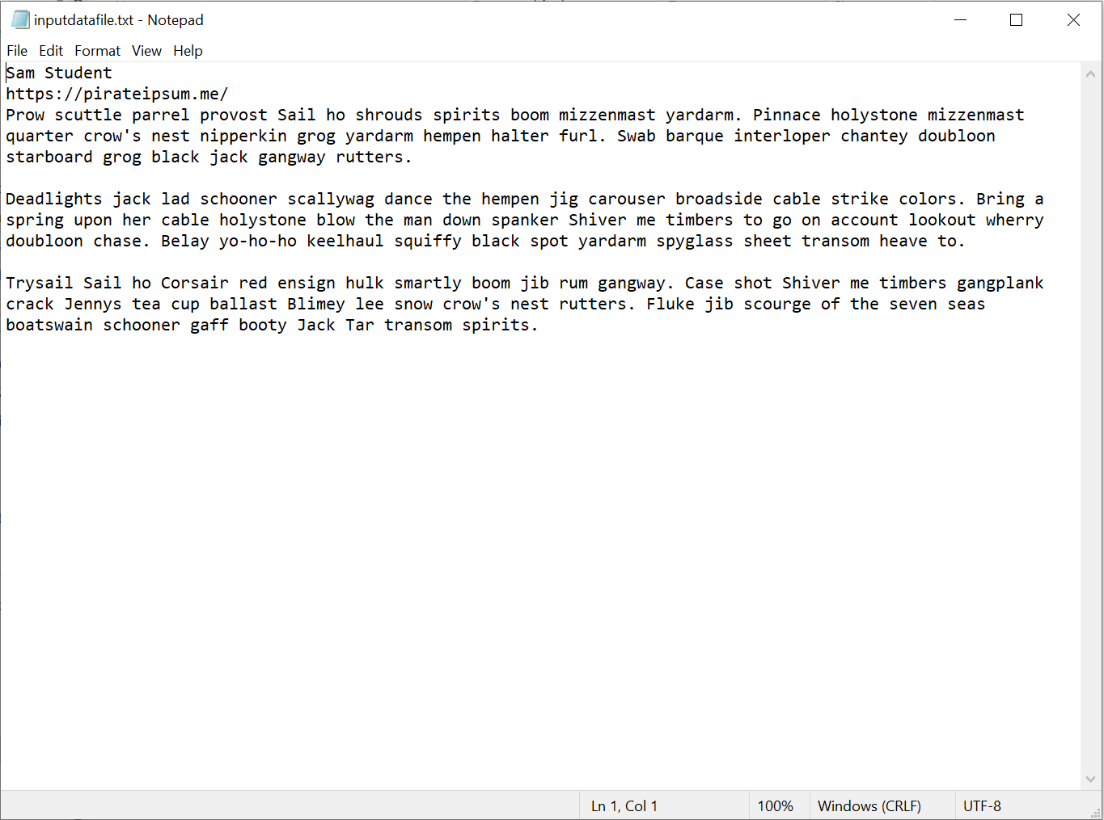

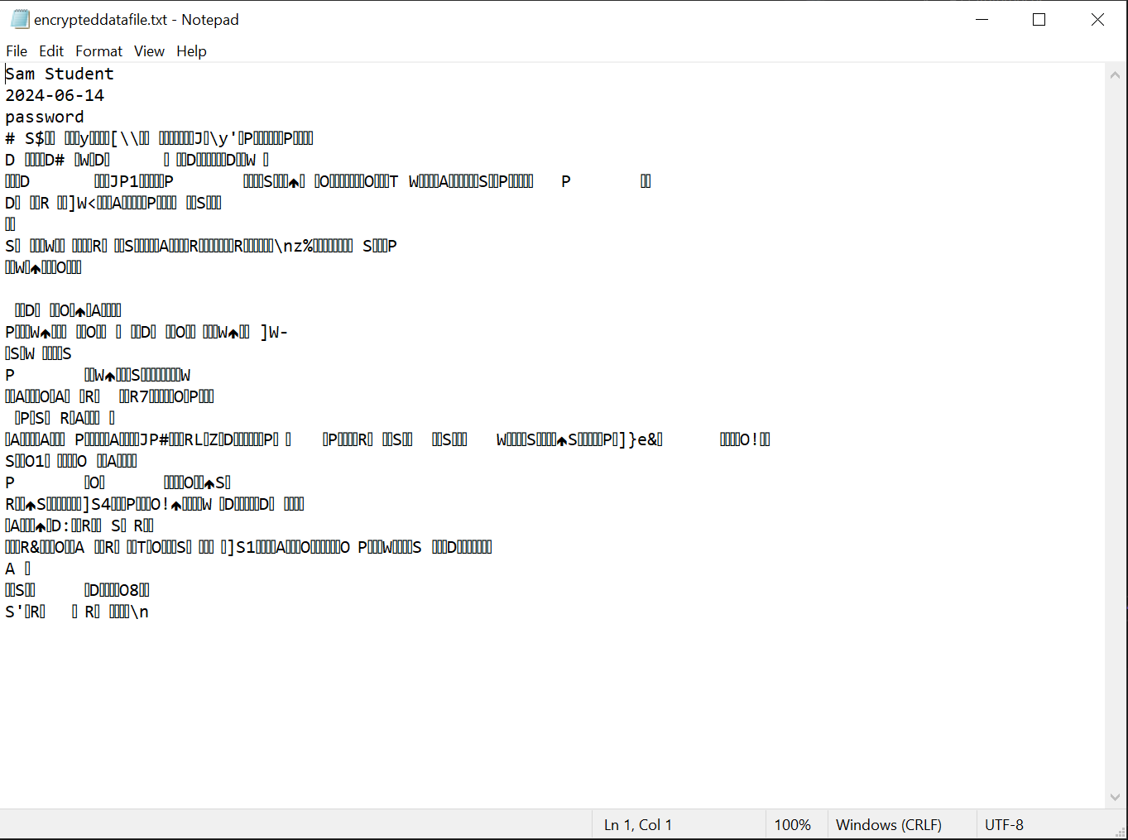

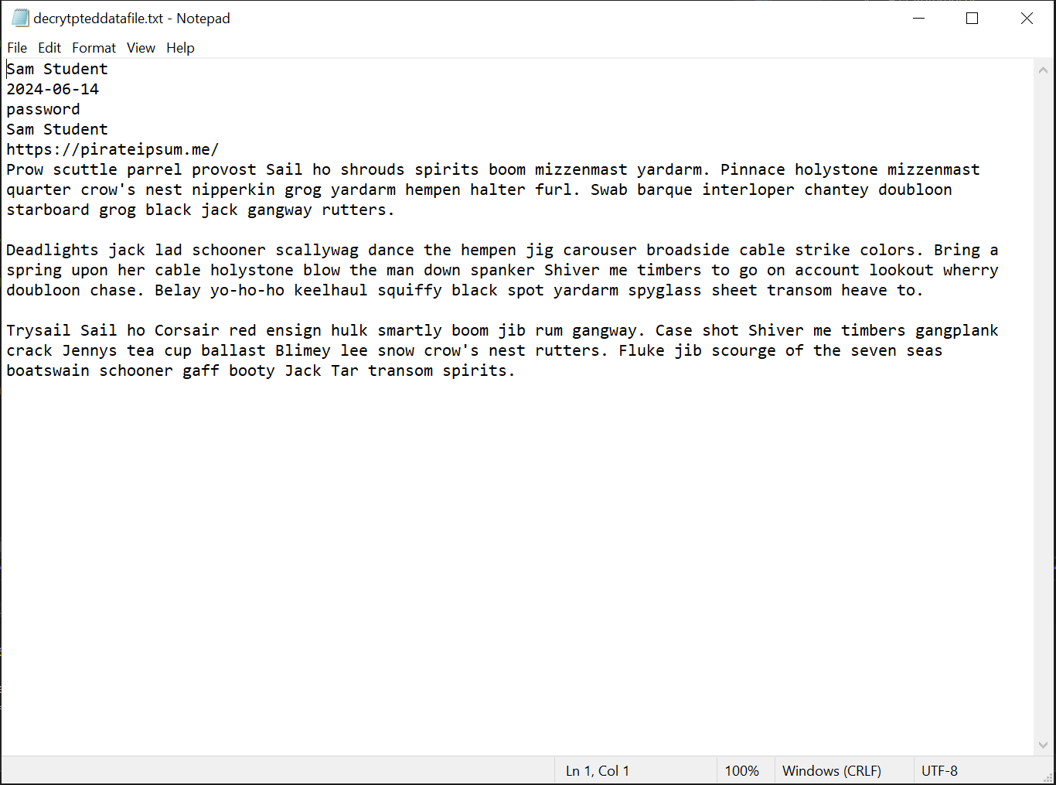

As seen in the first screenshot, the program read the input file, encrypted it and decrypted it. An XOR operation was used to encrypt the data on the input file. This file is then saved to a new text file. The encrypted file is then decrypted to reveal the same data as the input file but with the student’s name and time stamp added. When writing the code, I did run into one error where I tried to use the localtime function but found it was deprecated and replaced with localtime_s. I made sure to make a comment on that line so other maintainers would know why localtime function is no longer used. Error handling and error messages were put in place for each time a file is opened. This way the program will let the user know if there was an error when trying to open any of the files.